Wise Words: The Magic Invitational
Gary Wise
This week's Wise Words comes to you from the brief time before Pro Tour-New York and after the Invitational announcements. What follows is a collection of thoughts and facts gathered throughout the week.

THANKS
First and foremost, I want to send out thanks to everyone who voted, regardless of whether or not you voted for me. Each year, more and more people are voting, increasing the vote's credibility, and with it the Invitational's. Good job guys, and a special thanks to those who helped get me to Cape Town. I'll be thinking about you while I'm there.

THE VOTE
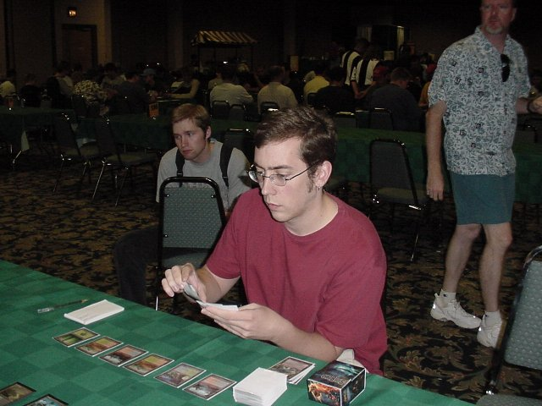
With anticipation of the Invitational vote came a lot of discussion about who should and should not go, and the announcement that Chris Pikula, Dave Price, Brian Kibler and I had been selected heightened the talk. Of particular note to me was an edited caption that came from the GP-Denver coverage that said "Pro players discuss the Invitational vote. They feel Gary Wise is the most undeserving."
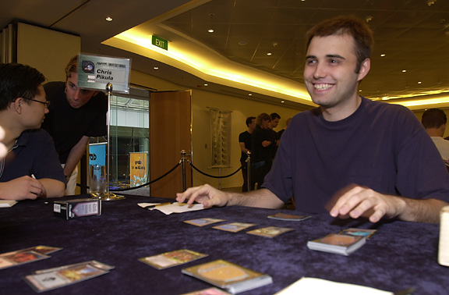
My initial reaction to this was to feel a little wounded by those notions, until I realized that essentially, the players in question were just talking. My Pro Tour season aside, it's my contention that whomever gets voted in is the MOST deserving, simply because those are the players the world wants to see play Magic. The question is what is it that set Dave Price, Brian Kibler, Chris Pikula and I apart enough that we were the ones who were voted in.
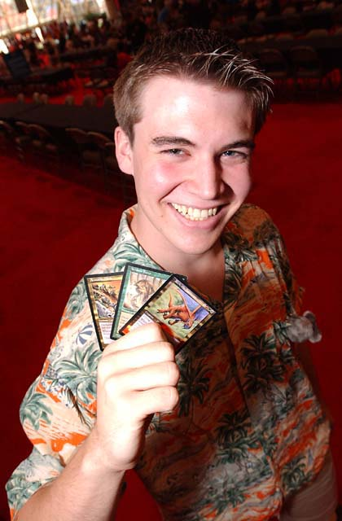
I think at its base, the simple answer to this question is the combination of fun and communal contribution. Dave has been writing Magic articles since before the invention of the pen, Chris may be the best story teller I've ever met and Brian plays cards like Rith, Draco and Ertai in Constructed Pro Tours. All four of us have been known to write from time to time and are social beings, though Chris's articles have been replaced by his card Meddling Mage, which no doubt has been a major part of his lingering popularity despite three Pro Tour points last season.
The point is that the reason the four of us got invited is because we're well known not just as Pro Tour participants, but also as Pro Tour personalities. I don't write articles to get invited to exotic locales, that is just a Christmas bonus of sorts. Next time you hear the Ryan Fuller's, Chris Benafel's and Dave Williams's of the world telling you about how some of their friends are more deserving, remind them that for the entire year, that friend has been looking out for number one while the players who eventually get invited are looking out for everyone else. As soon as they realize the Invitational is a promotional tournament for the game and not a reward for being born talented, maybe they'll get away from that singular mentality.

WHO DID WE FORGET?
While I have no problems with the players who got in, there are a few who I'd love to add to the present roster of 16 if given the option. In actuality, I'd probably take the present roster to nineteen if asked to exercise restraint:
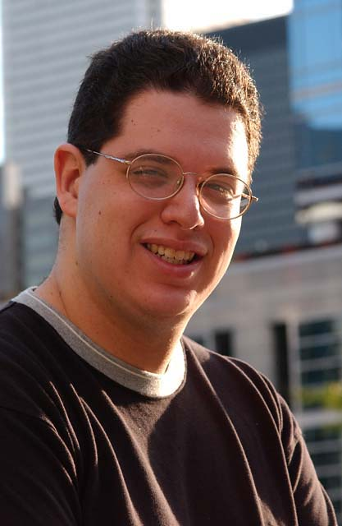
Mike Turian - Potato this, potato that, Potato Nation, potato chips, potato latkes... I think the whole potato image that has come to accompany the name Mike Turian may actually be detracting from the reputation this serious talent should be getting. Mike is the only person I openly lobbied for and I'll do it again next year for three reasons: 1) He may well be the greatest guy on Pro Tour. 2) He's making a community contribution now, and not just one of those 'it-is-a-week-before-the-Invitational-vote-so-I'd-better-write-an-article-to-heighten-my-vote-potential' contributions. Mike has become a regular columnist on Mindripper, only writing when he has something to say and generally making a lot of sense most of the time. 3) Long considered among the Top 5 Limited players in the world, Turian only made Top 8 at Worlds and broke the Masques team Rochester format, a major reason Potato Nation won PT-NY. I think those are three pretty good reasons.
Scott Johns - Does anyone realize what an amazing season Scott just had? If you were to ask me if I'd rather have strong peak performances or be consistent, I'd tell you I'd want to be like Scott, consistent. Like Turian, he started out the year with the win at New York, but instead of losing the drive as many champions have in the past, he just kept on winning, finishing in the money in every Pro Tour in the 2000-2001 season. Having now finished in the Top 64 of an amazing eight consecutive Pro Tours, Scott also has five third day appearances, contributes to the community with his editing job at www.mindripper.com and has been one of the most instrumental deck builders in the world for years. Throw in the fact that last year's system would have earned him an invite and that he was tied in the Player of the Year race with Dan Clegg, who earned an invite as top North American pro point player (Dan won the tiebreak thanks to composite rating) and you have the player who appears to have been the most slighted if you look at the numbers.
Ben Rubin - Ben, who finished in fifth by a mere nine votes, had what by his standards could only be considered a horrible season, but that fact should have been eclipsed by his insane 13-1 record in Masters matches. Winner of two of the three singles Masters events held this year, Ben hardly needed further reward in addition to the $60,000 he won in those three tournaments by consistently beating the world's best, but this is a matter of respect, and those performances probably should have earned the trip to Cape Town.

CHILDREN OF THE GRAND PRIX CIRCUIT

This really shows the changing face of the Pro Tour and how important the Grand Prix has become...
One effect of the introduction of the Masters this year is that those players who are willing to travel to more tourneys than most will often see the results in their pro point totals. With all the talk of who would and would not be attending the Invitational, it became pretty obvious that this would be the first year in which GP travels would have a profound effect on who would attend the Pro Tour's most enjoyable stop.
Now it's important to note here that the Grand Prix is a fully legitimate way to earn those much-valued pro points. Those guys who make the choice to travel the planet are paying a lot of money in airfare and hotel so that they can earn the pro points needed for qualification in the Masters, with the Invitational being their bonus. Once at the tournaments, it isn't easy to do well every time, with players like Chris Benafel and Ryan Fuller showing remarkable consistency.
I took a look at those players who were sitting atop the season-end standings and added up the number of points they'd accumulated at Pro Tours alone, and the result showed that Grand Prix finishes actually resulted in three of the nine Pro Tour point spots going to one player instead of another. Here's a look at the Pro Tour-only Invitational and the real McCoy:
Spot | Real Invitational | PT points winner
Returning Champ: | Jon Finkel | Jon Finkel
World Champ: | Tom Van de Logt | Tom Van de Logt
DCI Rating: | Antoine Ruel | Antoine Ruel
Pro Points: | Kai Budde | Kai Budde
 | Kamiel Cornelisson | Kamiel Cornelisson
 | Mike Pustilnik | Zvi Mowshowitz
 | Chris Benafel | Mike Pustilnik
 | Zvi Mowshowitz | Mike Turian
Top North American: | Dan Clegg | Scott Johns
Top European: | Ryan Fuller | Patrick Mello
Top APAC: | Tsoyoshi Fujita | Tsoyoshi Fujita
Top Latin American: | Scott Richards | Scott Richards
Top vote getters: | Dave Price | ?????
 | Gary Wise | ?????
 | Brian Kibler | ?????
 | Chris Pikula | ?????
With his strong finish at Worlds, Mike Turian snuck into fifth place among the top pro points earners at Premiere-level events, while Chris Benafel did not crack the top 10. Likewise, Dan Clegg with his two Day 3 appearances this year, would only have finished fourth for the North American spot, with Scott Johns, me and Rob Dougherty all finishing ahead of him. Ryan Fuller would have placed nine points behind the Pro Tour season's forgotten success story, Patrick Mello, with Ben Klauser coming second despite the Austrian not attending the team PT in New York.
This really shows the changing face of the Pro Tour and how important the Grand Prix has become. Benafel, Clegg and Fuller, like those writers invited to the Invitational, absolutely deserve their spots, having dedicated more time and financial resources to the game then those ahead of them at Pro Tours. While the writers engage in an endeavor that puts them in a more public light, these guys are legitimizing the idea of playing as a professional and deserve all the credit in the world. Just remember that the end of year stats don't tell the whole story.

YOU'D THINK FORMING A TEAM WOULD BE EASIER...
One of the problems that had to be anticipated with the invention of the Team PT is the making or breaking of friendships for competitive purposes. Peter Szigeti and Brian Hubble were teammates as recently as GP-Columbus, but as internet observers hay have noted, they're definitely on the outs now. Here's the scenario that took them from teammates to adversaries:
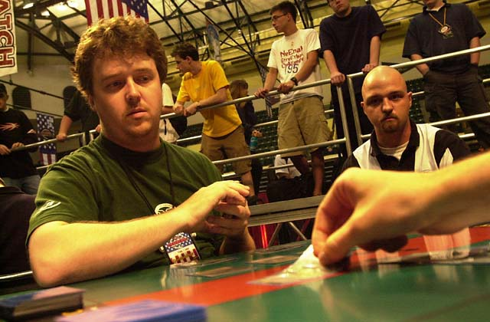
A month ago, I was putting together information about who would be teaming with whom for New York. When I called Hubble, he said he's be teaming with Szigeti and Jay Elarar, while Brian Selden and Alan Comer decided that with Kurt Burgner no longer playing regularly, it was time to look for a new third. Around this time, Terry Tsang was agreeing to form a team with Phil Freneau and Brian Hegstad.
Problems began when Szigeti started looking for the bigger, better deal. He approached Selden and Comer about the possibility of teaming with them, and Selden, who has been friends with Szigeti for some time told him there was a solid possibility, so Peter wasn't locking himself in anywhere, while Hubble and Elarar figured they had a team.
Hubble, Szigeti and Selden teamed up for Columbus with Comer absent, and things didn't go as well as they'd have liked, so when Selden and Comer spoke again before Worlds, they agreed that they should approach Ben Klauser, easily the top pro points player available, about being their third. They did so and Ben accepted their offer, much to Peter's disappointment. Thing is, with Peter being non-committal, Hubble decided it was time to ensure himself a place in PT-NY, so he agreed to a team up with Mike Long and Trevor Blackwell.
So, going into Worlds, Szigeti was without a team but thought he still had two options, with Comer and Selden not having told him about their decision. When they finally did, Peter was not pleased and all ties were cut, but with Hubble no longer available, Szigeti suddenly found himself without a team. He started talking to Freneau and Hegstad, who were pretty much set on playing with Terry Tsang, just as Klauser dropped a bomb on Comer and Selden.
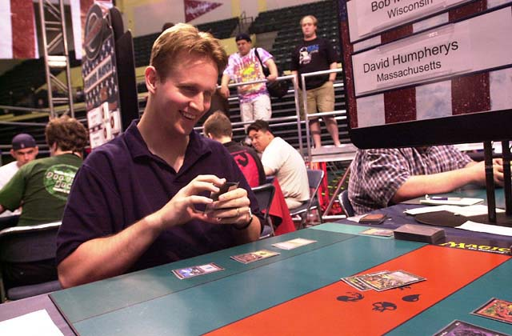
Turns out that Dave Williams and Bob Maher were without a third, and at Worlds they approached Ben, who decided he couldn't pass up that kind of opportunity despite having committed to Selden and Comer, whose Team Games Empire finished second at PT-DC. Brian approached Ben to talk about team strategy and Klauser only then said 'we need to talk', at which point the Californians knew something was up. Now, they were suddenly without a third again, with their backup plan alienated.
With Worlds done, Szigeti was without a team and Comer and Selden without a third, but with all that had transpired, a union between the three just wasn't in the cards. Szigeti approached Hegstad and Freneau one last time and convinced them to 'trade' Tsang to the Californians so all six could participate happily in the PT. The end result: four teams, Freneau-Hegstad-Szigeti, Comer-Selden-Tsang, Hubble-Long-Blackwell and Williams-Maher-Klauser are formed. Only in Hollywood.
This week, I deleted some 400 old emails that had been sitting in my in box for over two months as they were mostly either filled with comments on articles of long ago or decklists from since changed or deceased Constructed formats. If you were one of the people who didn't get a reply, I apologize, but I've just been unable to keep up with the email flow, resulting in my discontinuing the practice of including my email address. I hope you'll forgive and understand. Have a good week.

